Smart House Weather – User Acceptance Testing

This is a form to fill in User Acceptance Testing of the Smart House/Weather Dashboard. Please fill in the sections of each table highlighted in yellow. Please refer to the User Manual section of this document for full instructions on how to use the Smart House/Weather Dashboard. See screenshots in User Manual section for what expected results are supposed to look like. The weather is exclusively for the Digitech Smart House location at Adastral Park, Martlesham, Ipswich, Suffolk, United Kingdom and is NOT for your current location. You should not get weather for your current location unless you are currently at University of Suffolk Digitech Campus, the Digitech Smart House, Adastral Park, Martlesham, Martlesham Heath or Ipswich.

# Landing (Home) Page

|  |  |
| --- | --- |
| Label | Value |
| Name | Landing Page |
| Description | Access the Landing (Home) Page |
| Reporter (Your Name) | Alexander Robertson |
| Completion Date | 13/12/2024 |
| Test Case Steps | 1. Go to <https://dissertation-smart-home-weather-dashboard.onrender.com/> 2. [View the temperature and humidity](https://dissertation-smart-home-weather-dashboard.onrender.com/). Click the C/F toggle switch on the Temperature section to convert the temperature between Celsius and Fahrenheit. 3. Click the button links to ‘Details’ for both Temperature and Humidity. 4. Click the link to Weather in Navigation Bar. |
| Expected Result | Successfully loaded the Smart House / Weather Dashboard and display the outdoor temperature and humidities. Clicking the C/F toggle switch in the temperature section will convert the temperature between Celsius and Fahrenheit. Clicking the temperature Details button will take you to the temperature details page. Clicking the humidity Details button will take you to the humidity details page. Clicking the weather button will take you to the weather dashboard page. |
| Actual Outcome (Your answer here) | Landing page successfully loaded with outdoor temperature and humidities. I was able to toggle between celcius and farenheit for temperature. |
| Status (Pass or Fail) | Pass |
| URL | [https://dissertation-smart-home-weather-dashboard.onrender.com/](https://dissertation-smart-home-weather-dashboard.onrender.com/View the temperature and humidity)  [View the temperature and humidity](https://dissertation-smart-home-weather-dashboard.onrender.com/View the temperature and humidity) |
| Please put screenshots here: |  |
| Screen Size | 16 inch |
| Operating system on your device | macOS Sequoia |
| Browser(s) on your device used to access the Smart House Weather Dashboard. | Safari |
| Notes | Everything seems OK |

# Temperature Page

|  |  |
| --- | --- |
| Label | Value |
| Name | Temperature |
| Description | View the indoor and outdoor temperature of the Digitech Smart House. |
| Reporter (Your Name) | Alexander Robertson |
| Completion Date | 13/12/2024 |
| Test Case Steps | 1. Go to <https://dissertation-smart-home-weather-dashboard.onrender.com/temperature> 2. View the indoor and outdoor temperatures of the Smart House. 3. Click the C/F toggle switches to convert both temperatures between Celsius and Fahrenheit. 4. View the hourly temperature graph. 5. View the daily temperature graph. 6. View the monthly temperature graph. 7. Click the back button (desktop devices only) 8. Use the back button on browser if back button on page is not visible due to small display or ow screen resolution. 9. Swipe back go back to previous screen (mobile devices only) |
| Expected Result | Indoor and outdoor temperatures are available. Clicking the C/F toggle switches will change the temperatures between Celsius and Fahrenheit. Hourly temperature shows hourly temperatures over the last 24 hours as a bar chart. Daily temperature graph shows the daily temperatures over last 30 days as a line graph. Monthly temperature shows monthly temperatures over the last 12 months from January to December as a line graph. Back button takes you back to home (landing) page (desktop devices only). |
| Actual Outcome (Your answer here) | Successfully loaded temperature page, able to toggle between celcius and farenheit for both temperatures. Hourly and daily temperature graphs loaded. Data for April was missing in the monthly temperature graph (fail). |
| Status (Pass or Fail) | Fail |
| URL | <https://dissertation-smart-home-weather-dashboard.onrender.com/temperature> |
| Please put screenshots here: |  |
| Screen Size | 16 inch |
| Operating system on your device | macOS Sequoia |
| Browser(s) on your device used to access the Smart House Weather Dashboard. | Safari |
| Notes | Fix historical monthly data so April temperature is shown. |

# Humidity Page

|  |  |
| --- | --- |
| Label | Value |
| Name | Humidity |
| Description | View the indoor and outdoor temperature of the Digitech Smart House. |
| Reporter (Your Name) | Alexander Robertson |
| Completion Date | 13/12/2024 |
| Test Case Steps | 1. Go to <https://dissertation-smart-home-weather-dashboard.onrender.com/humidity> 2. View the indoor and outdoor humidities of the Smart House. 3. View the hourly humidity graph. 4. View the daily humidity graph. 5. View the monthly humidity graph. 6. Click the back button (desktop devices only) 7. Use the back button on browser if back button on page is not visible due to small display or ow screen resolution. 8. Swipe back go back to previous screen (mobile devices only) |
| Expected Result | Indoor and outdoor humidities are available. Hourly humidity graph shows hourly humidities over the last 24 hours as a bar chart. Daily humidity graph shows the daily humidities over last 30 days as a line graph. Monthly humidity shows monthly humidities over the last 12 months from January to December as a line graph. Back button takes you back to home (landing) page (desktop devices only). |
| Actual Outcome (Your answer here) | Successfully loaded humidity page and displayed both outdoor and indoor humidity. Hourly and daily humidity graphs are displayed correctly however April is missing from the monthly humidity graph (fail). |
| Status (Pass or Fail) | Fail |
| URL | <https://dissertation-smart-home-weather-dashboard.onrender.com/humidity> |
| Please put screenshots here: |  |
| Screen Size | 16 inch |
| Operating system on your device | macOS Sequoia |
| Browser(s) on your device used to access the Smart House Weather Dashboard. | Safari |
| Notes | Please fix the historic humidity data for April. |

# Weather Dashboard

|  |  |
| --- | --- |
| Label | Value |
| Name | Weather Dashboard |
| Description | View the weather dashboard. |
| Reporter (Your Name) | Alexander Robertson |
| Completion Date | 13/12/2024 |
| Test Case Steps | 1. Go to <https://dissertation-smart-home-weather-dashboard.onrender.com/weather> 2. View all parts of the weather dashboard. 3. Toggle between Celsius and Fahrenheit using the C/F toggle switches in Temperature and Feels Like. 4. Toggle between mph and km/h on the wind section of the dashboard. 5. Toggle between miles and kilometres in the visibility section of the dashboard. 6. View time, clock, date, and calendar (desktop devices only – not available on mobile devices). 7. View hourly weather forecast. 8. View daily weather forecast. 9. Click the “View Full Weather Map” button beneath the map on the weather dashboard. |
| Expected Result | Successfully loads the weather dashboard containing:   * Temperature that can be toggled/converted between Celsius and Fahrenheit. * Current Weather conditions for Ipswich (NOT your local area) * Feels Like temperature that can be toggled/converted between Celsius and Fahrenheit. * UV Index, * Humidity, * Wind speed that can be toggled/converted between mph/kmh, wind direction description and as a compass. * Air pressure * Air pollution level * Precipitation chance/probability * Pollen count for Grass, Trees, and Weeds. * Visibility, can be toggled between miles and kilometres, * Weather map (precipitation) with working link to full weather maps page.   Successfully loads time, animated clock displaying correct time, date, calendar (desktop devices only – does not show on mobile devices.  Hourly (24 hours) weather forecast displaying time, temperature, and weather conditions.  Daily weather (5 days) forecast showing day, temperature, weather conditions, precipitation chance, wind speed, wind direction and humidity. |
| Actual Outcome (Your answer here). | Successfully loaded the weather dashboard with all the content displayed in the expected outcome. Successfully loaded date, time, calendar and clock widget on the side of the page as stated in the expected outcome. Successfully loaded the hourly and daily weather forecasts as expected. Was able to toggle between celcius/farenheit, mph/kmh, miles/kilometers. Was able to use the mini weather map. Was able to go to the full weather maps page. |
| Status (Pass or Fail) | Pass |
| URL | <https://dissertation-smart-home-weather-dashboard.onrender.com/weather> |
| Please put screenshots here: | A screenshot of a computer  Description automatically generated  A screenshot of a computer  Description automatically generated  A screenshot of a weather forecast  Description automatically generated  A screenshot of a weather forecast  Description automatically generated |
| Screen Size | 16 inch |
| Operating system on your device | macOS Sequoia |
| Browser(s) on your device used to access the Smart House Weather Dashboard. | Safari |
| Notes | OK but make the date and time dashboard line up with the main weather dashboard and make the daily weather forecast the same width as the hourly weather forecast (it will look better). |

# Weather Maps

|  |  |
| --- | --- |
| Label | Value |
| Name | Weather Maps |
| Description | View the weather maps for the Digitech Smart House in Martlesham, Ipswich. |
| Reporter (Your Name) | Alexander Robertson |
| Completion Date | 13/12/2024 |
| Test Case Steps | 1. Go to <https://dissertation-smart-home-weather-dashboard.onrender.com/weathermaps> 2. View the precipitation map, zoom, and move around the map. 3. View the temperature map, zoom, and move around the map. 4. View the wind map, zoom, and move around the map. 5. View the air quality map, zoom, and move around the map. 6. View the radar map, zoom, and move around the map. 7. Click the back button to go back to the main weather dashboard page (desktop devices only) |
| Expected Result | All five maps successfully load.  Precipitation map shows precipitation and precipitation type for Digitech Smart House location (Martlesham, Ipswich).  Temperature map shows temperature for Digitech Smart House location (Martlesham, Ipswich).  Wind Map shows wind for Digitech Smart House location (Martlesham, Ipswich).  Air Quality Map shows air quality for Digitech Smart House location (Martlesham, Ipswich).  Radar Map shows radar for Digitech Smart House location (Martlesham, Ipswich).  Clicking the back button takes you back to the main weather dashboard page. |
| Actual Outcome (Your answer here) | Successfully loaded all five weather maps and I was able to navigate around them and zoom them. However it is difficult to scroll up and down this page as the curser must be in specific locations of the page as the maps interfere with scrolling (fail). |
| Status (Pass or Fail) | Fail |
| URL | <https://dissertation-smart-home-weather-dashboard.onrender.com/weathermaps> |
| Please put screenshots here: | A screenshot of a computer screen  Description automatically generated  A screenshot of a computer screen  Description automatically generated  A screenshot of a computer screen  Description automatically generated  A screenshot of a computer screen  Description automatically generated  A screenshot of a computer screen  Description automatically generated  A screenshot of a computer screen  Description automatically generated  A screenshot of a computer screen  Description automatically generated  A screenshot of a computer screen  Description automatically generated  A screenshot of a computer screen  Description automatically generated  A screenshot of a computer screen  Description automatically generated |
| Screen Size | 16 inch |
| Operating system on your device | macOS Sequoia |
| Browser(s) on your device used to access the Smart House Weather Dashboard. | Safari |
| Notes | The scrolling needs improvement as scrolling up and down the page is difficult and frustrating. |

# User Manual

## Access home page of Smart House Weather Dashboard

1. Go to <https://dissertation-smart-home-weather-dashboard.onrender.com/>

This page shows the outdoor temperature and humidity of the Digitech Smart House.

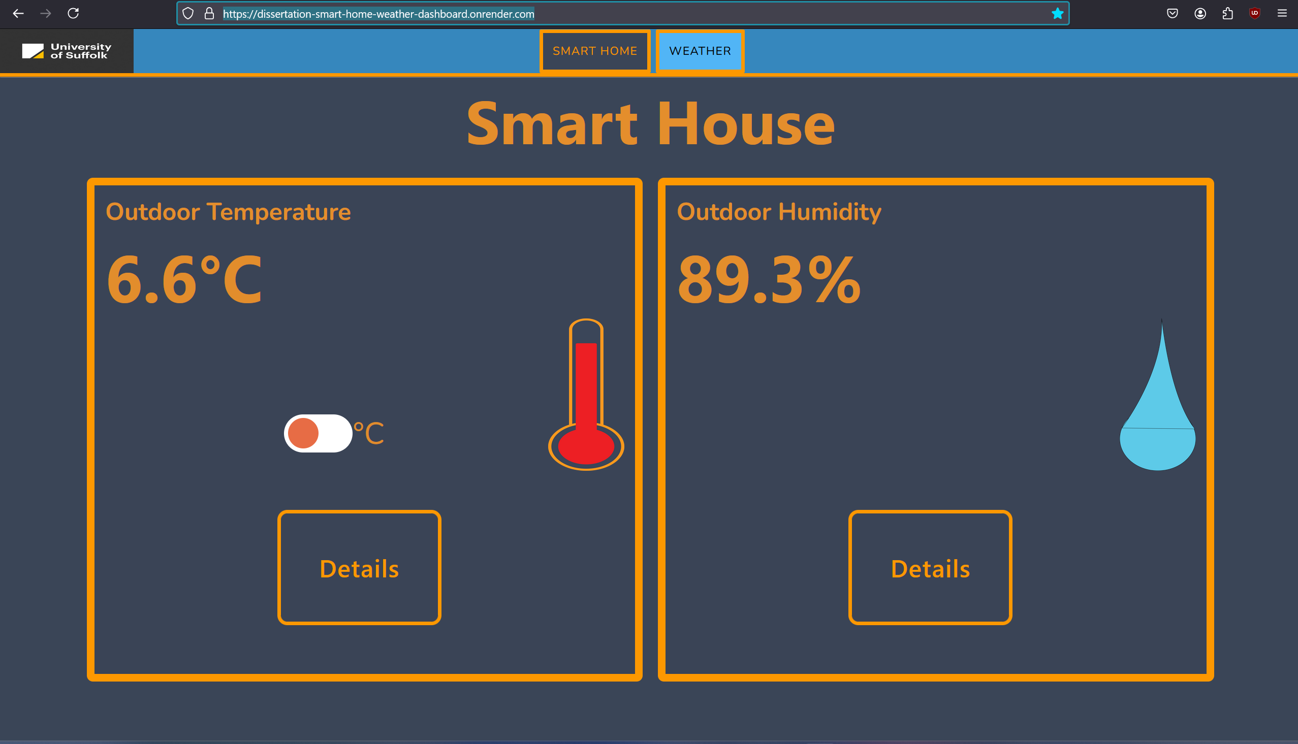

Figure - Smart House Dashboard Landing (Home) Page

1. Click the toggle switch on the Outdoor Temperature tile to convert temperature between Celsius and Fahrenheit.



Figure - Temperature in Celsius.

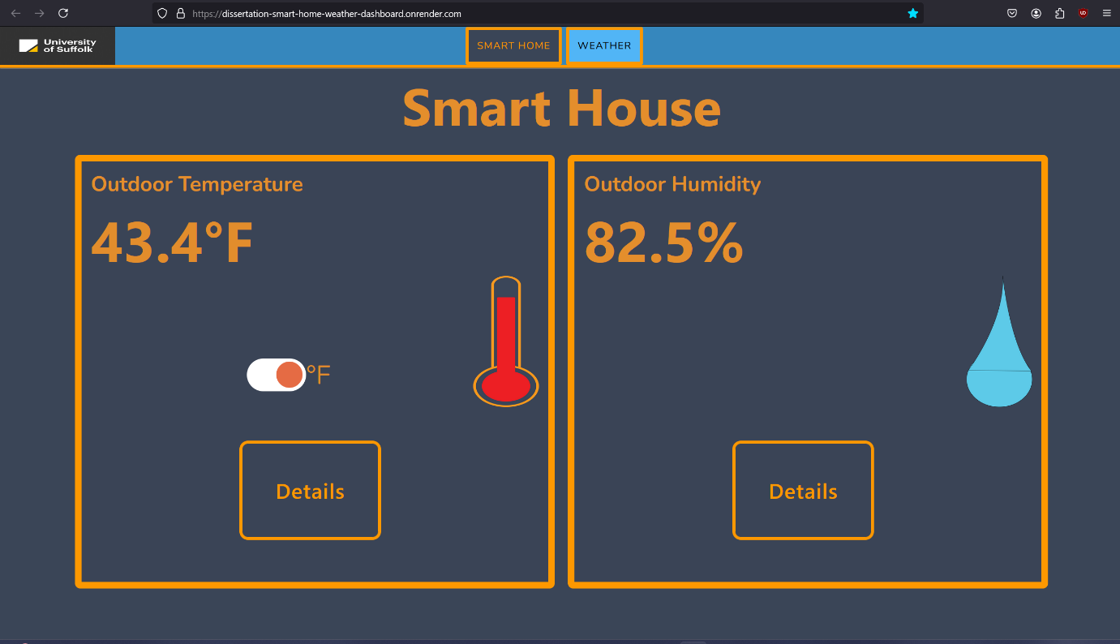

Figure - Temperature in Fahrenheit

## View Temperature Details

1. Click the Details button on the Outdoor Temperature tile.



Figure - Click the Details button for temperature.

1. View the indoor and outdoor temperature on the temperature details page.

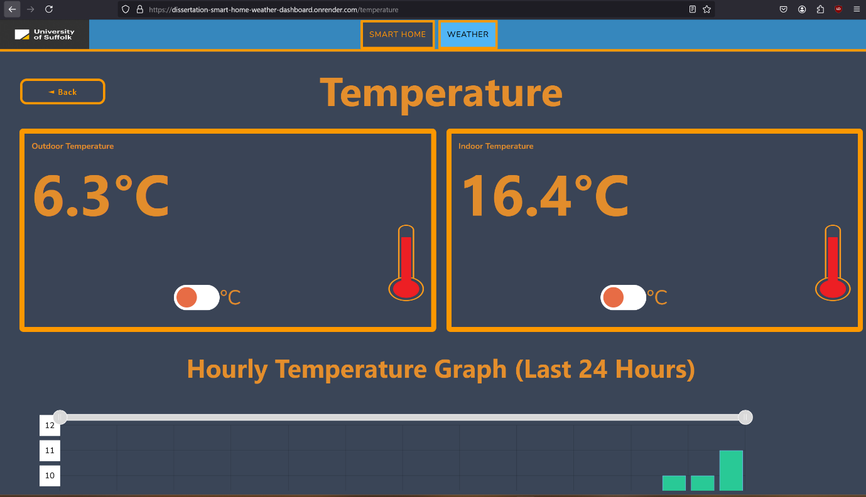

Figure - Temperature page showing indoor and outdoor temperatures.

1. Toggle between Celsius and Fahrenheit on the indoor and outdoor temperatures.

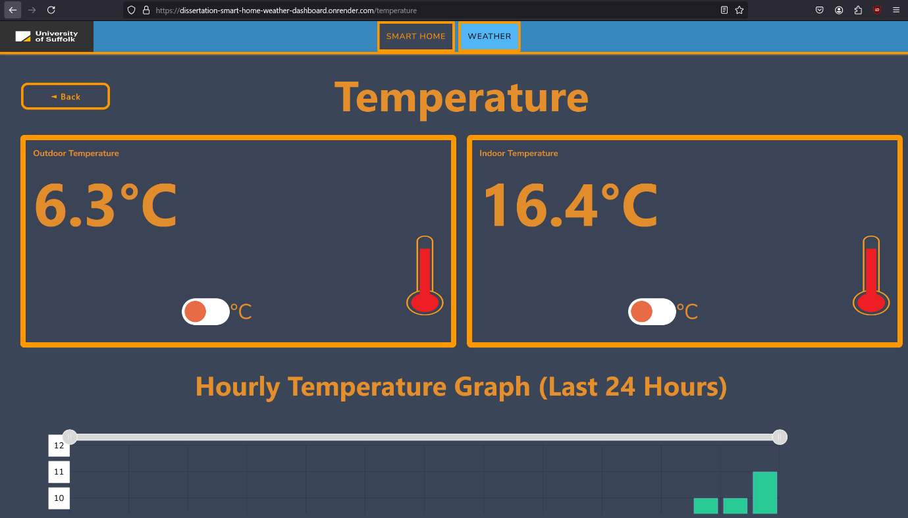

Figure - Indoor and outdoor temperatures in Celsius.

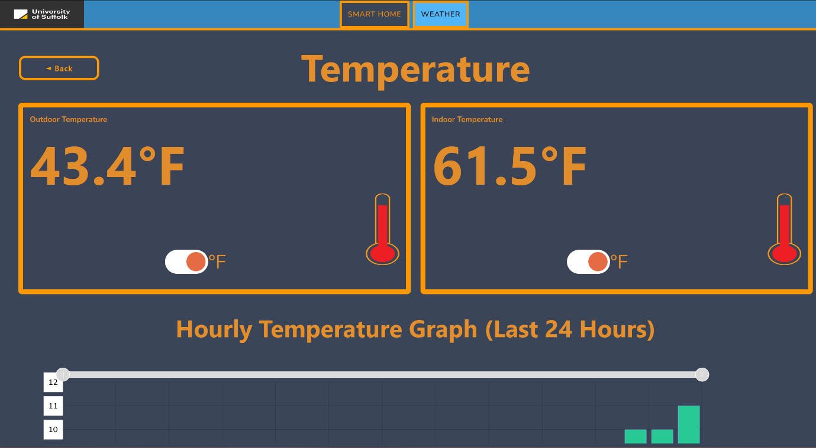

Figure - Indoor and outdoor temperatures in Fahrenheit.

1. View the hourly temperature graph.

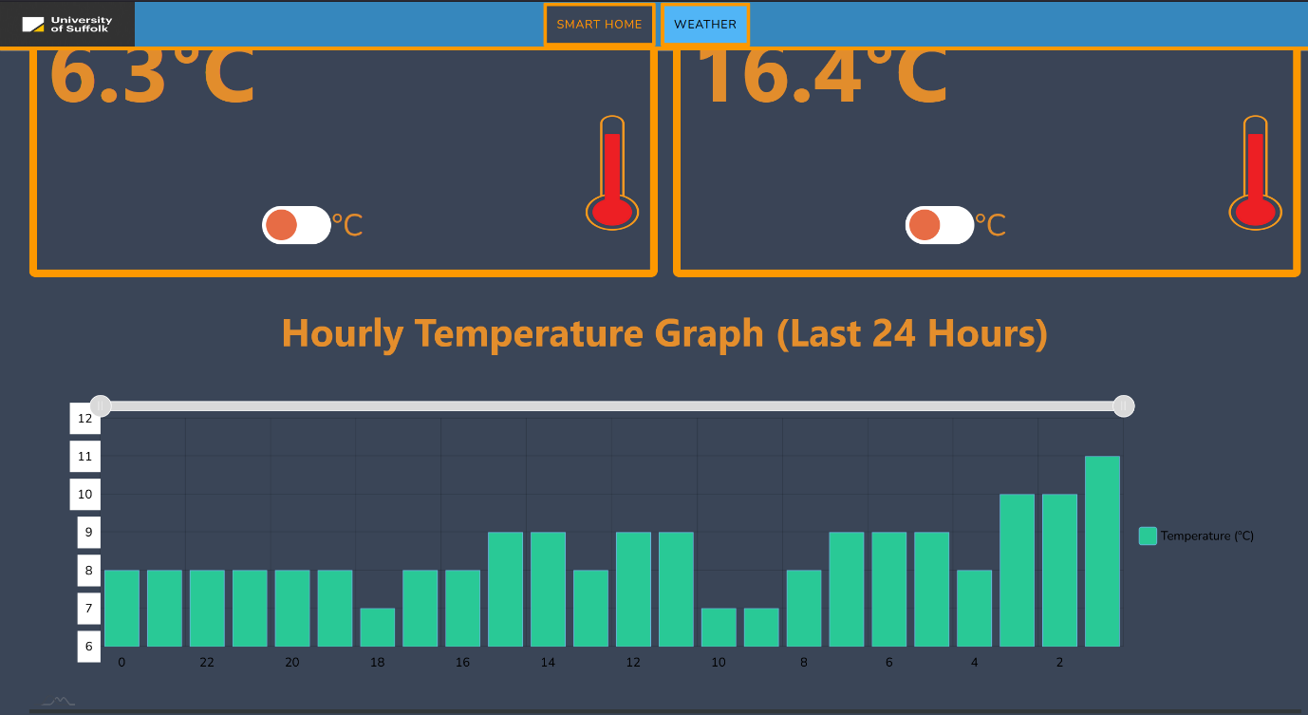

Figure - Hourly temperature graph on temperature page.

1. View the daily and monthly temperature graphs.

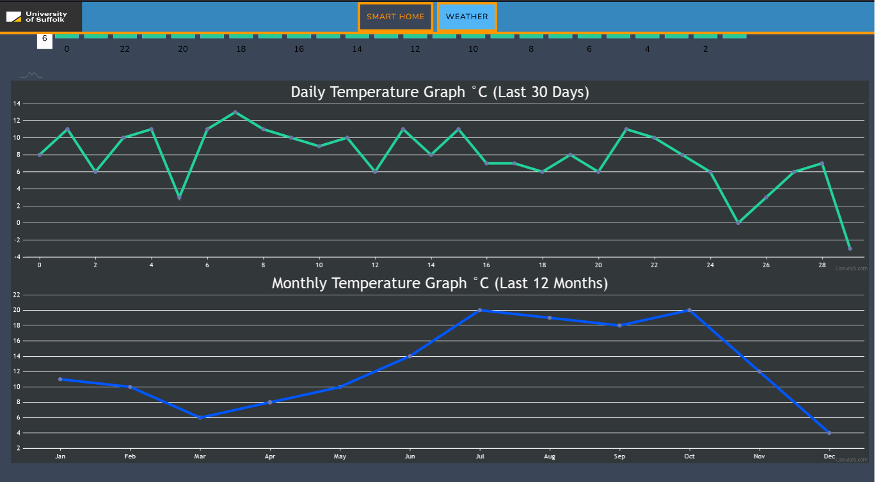

Figure - Daily and monthly temperature graphs on temperature page.

## View Humidity Details

1. Click the Details button on the Outdoor Humidity tile.



Figure - Click the Details on the humidity tile of the Smart House dashboard.

1. View the indoor and outdoor humidity on the humidity details page.

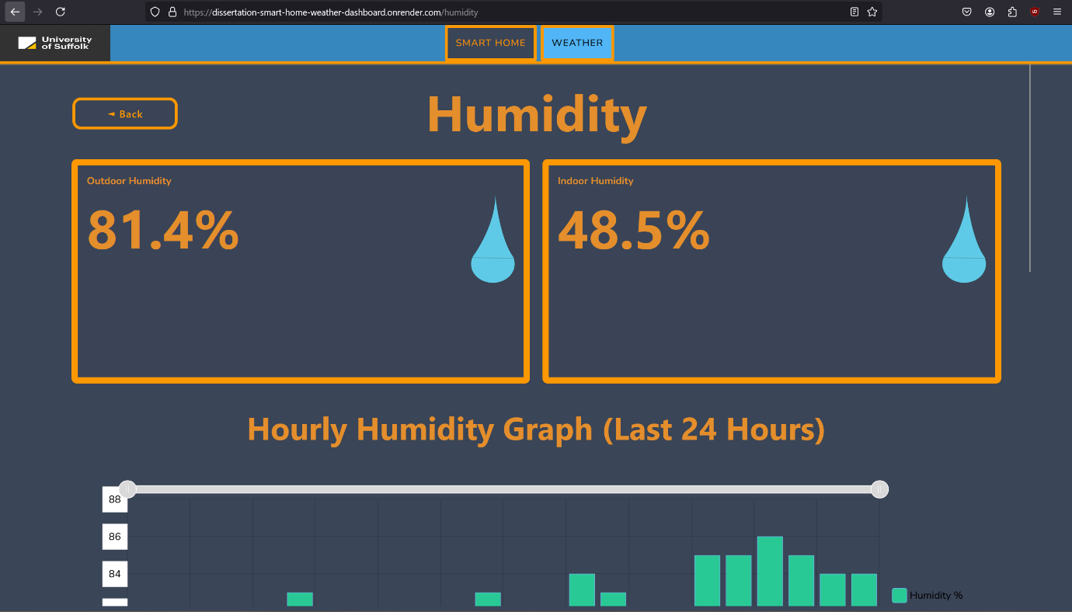

Figure - Humidity page with indoor and outdoor humidities.

1. View the hourly humidity graph.

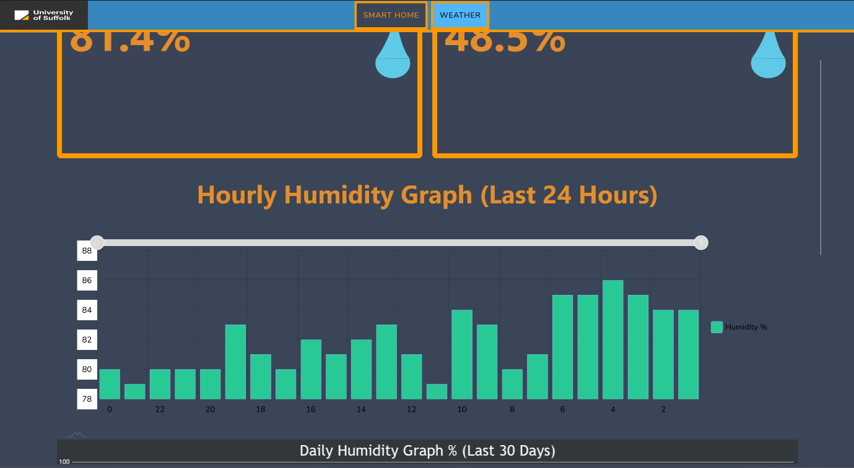

Figure - Hourly humidity graph on humidity page.

1. View the daily and monthly humidity graphs.

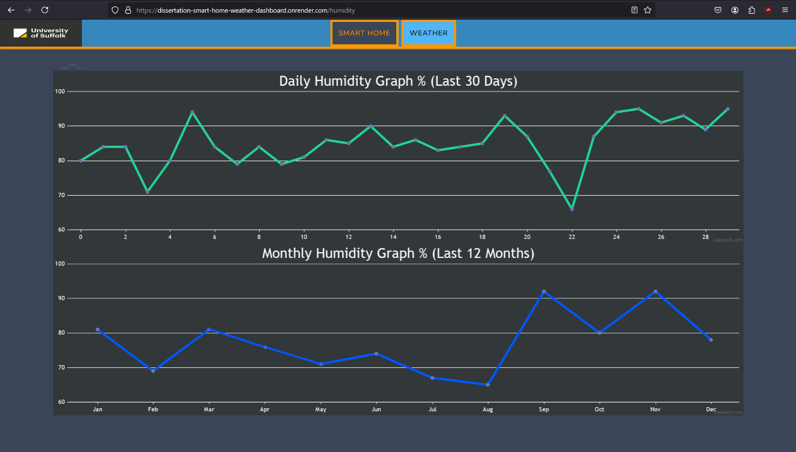

Figure - Daily and Monthly humidity graphs.

## View Weather Details

1. Click the Weather button on the navbar (desktop devices)



Figure - Click the Weather button in the navbar.



Figure - Navbar.

1. Click the hamburger menu (3 lines on the top right corner) for the menu to appear (mobile devices only).

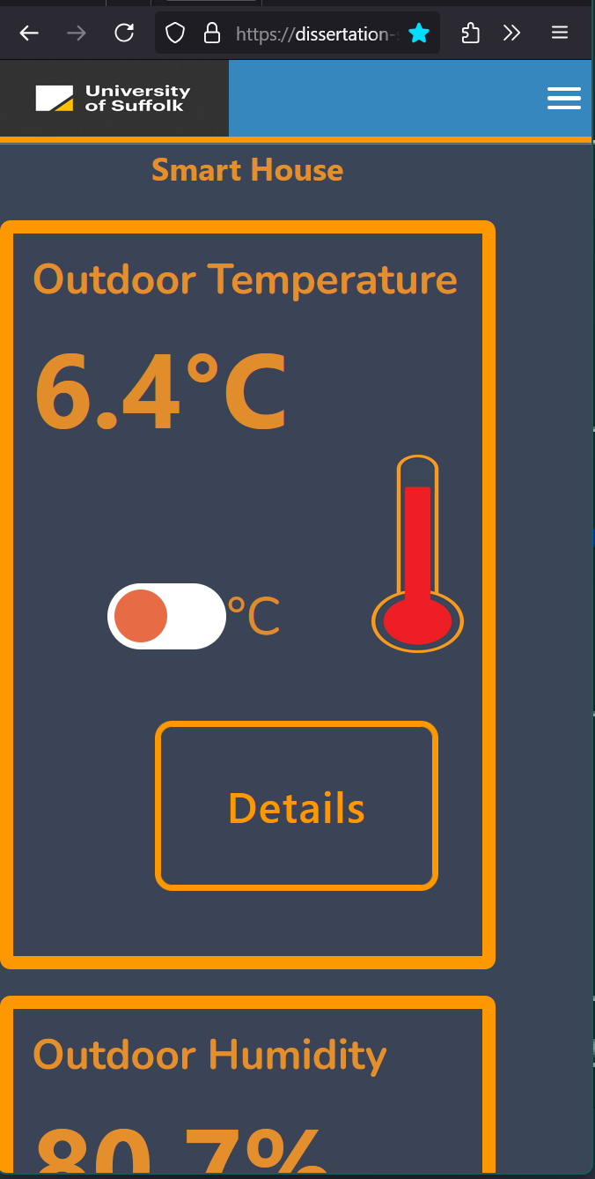

Figure - Tap the hamburger menu (three white lines) in the top right corner.

1. Click the Weather button on the menu (mobile devices only).

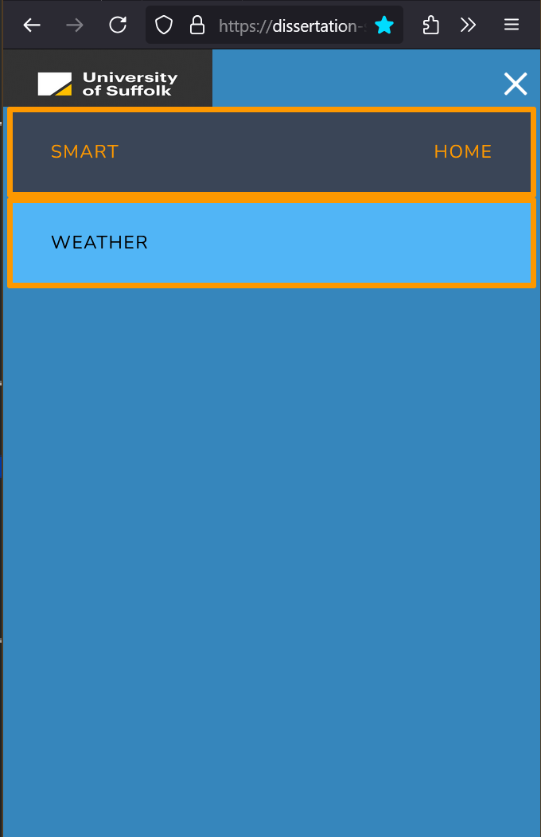

Figure - Tap the weather option from the menu that appears.

1. View the weather dashboard – It will display:
   1. Temperature
   2. Weather conditions
   3. Feels like temperature.
   4. UV index
   5. Humidity
   6. Wind: Speed, direction, and compass
   7. Air pressure
   8. Air pollution
   9. Precipitation probability as percentage
   10. Pollen count: Grass, Trees, Weeds
   11. Visibility
   12. Precipitation weather map.

Screenshot of weather dashboard on desktop device (layout may vary depending on screen size, resolution and web browser and device):

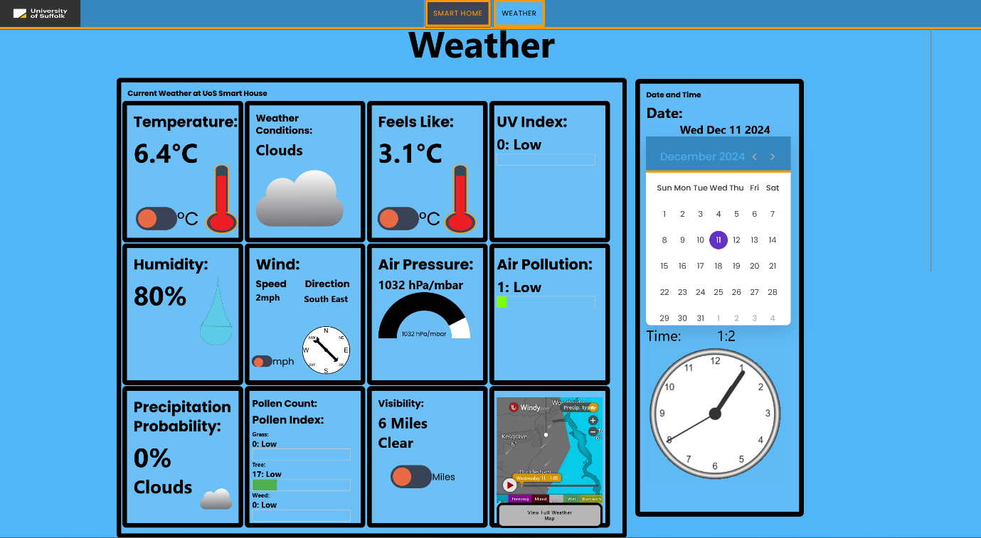

Figure - The weather dashboard on a desktop browser.

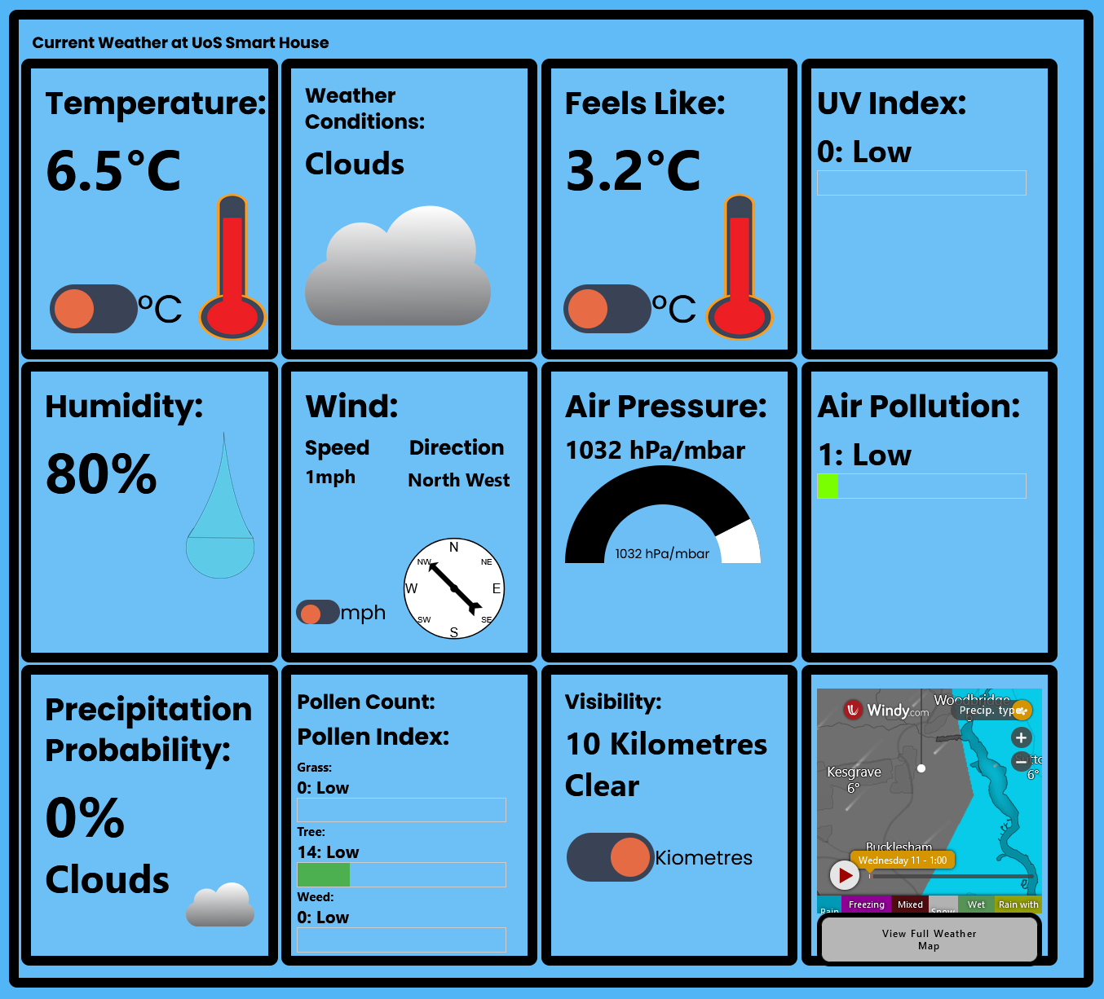

Figure - Dashboard close up screenshot.

Screenshot of weather dashboard on mobile device (layout may vary depending on screen size, resolution and web browser and device):

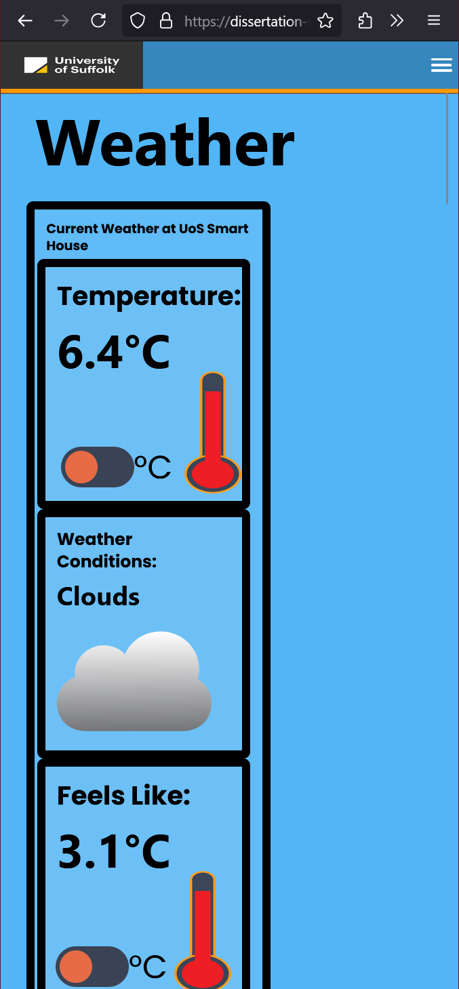

Figure - Dashboard on mobile device.

1. Toggle Temperature and Feels Like between Celsius and Fahrenheit.

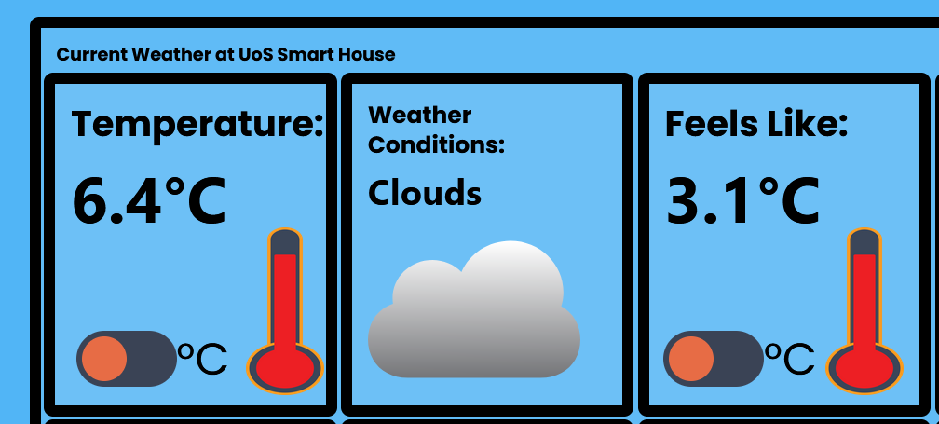

Figure - Temperature and Feels Like in Celsius.

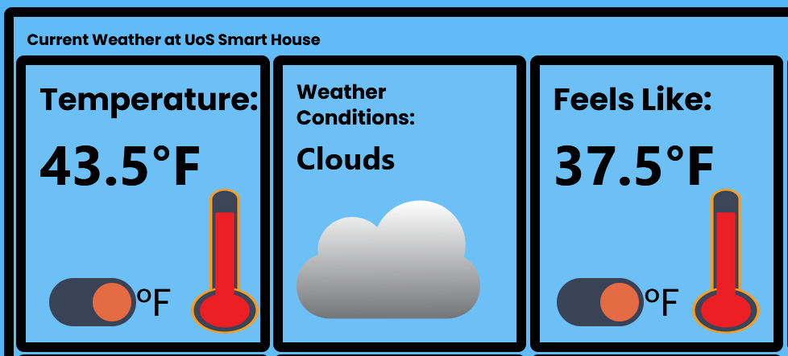

Figure - Temperature and Feels Like in Fahrenheit.

1. Toggle wind speed between mph and km/h.

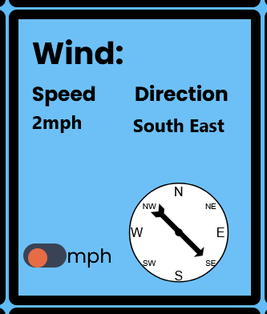

Figure - Wind speed in miles per hour.

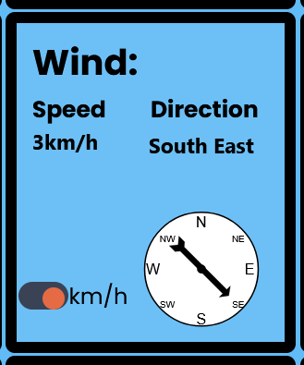

Figure - Wind speed in kilometres per hour.

1. Toggle visibility between miles and kilometres.

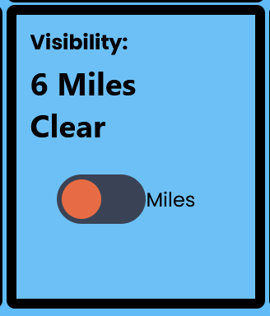

Figure - Visibility in miles.

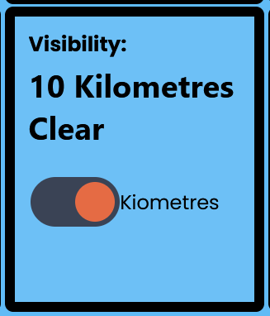

Figure - Visibility in kilometres.

1. View date and time widget with animated clock and calendar. PLEASE NOTE: This is only available on desktop devices and is unavailable on mobile devices.

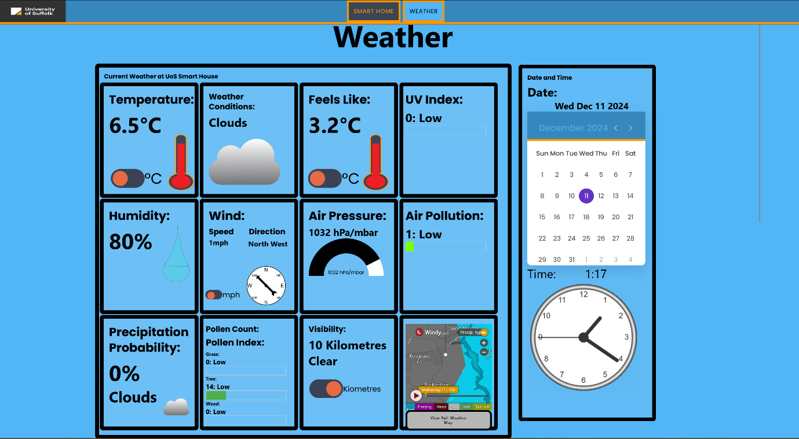

Figure - Date and time widget next to weather dashboard (desktop devices only).

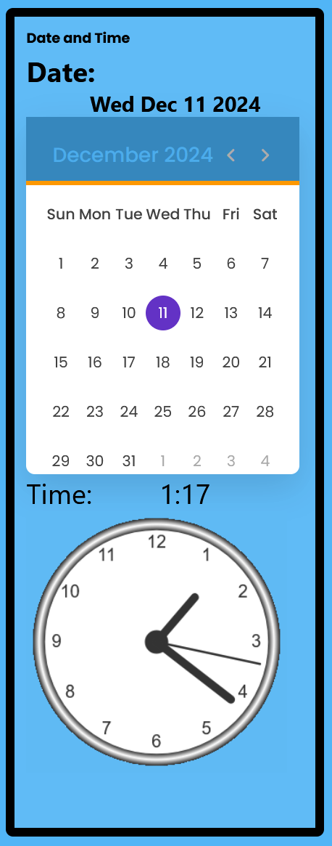

Figure - Close up of date and time widget.

1. View the hourly weather forecast. You may need to scroll the widget horizontally on smaller screens and mobile devices.

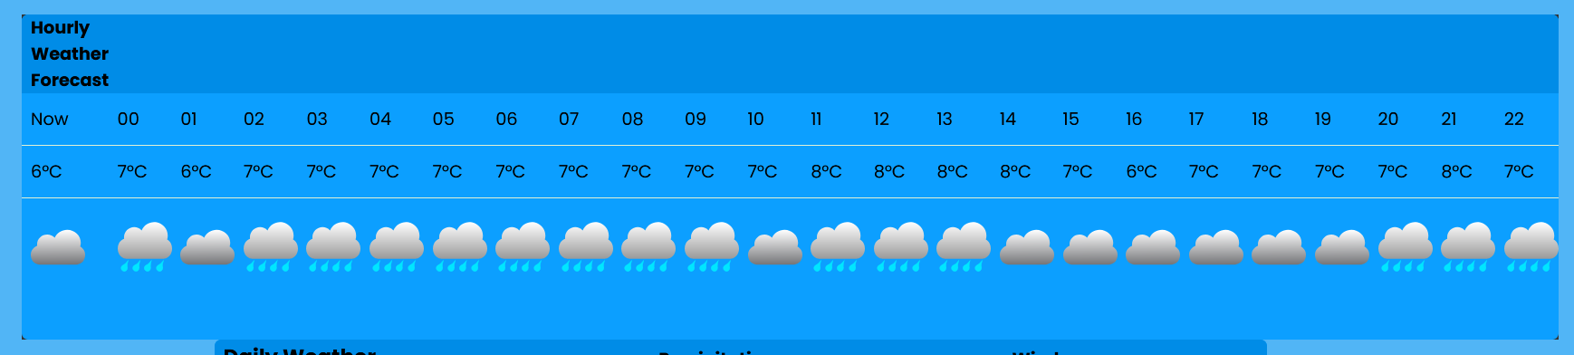

Figure - Hourly weather forecast.

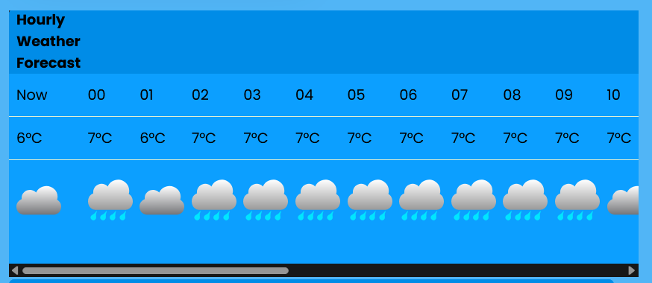

Figure - Hourly weather forecast with scroll bar.

1. View daily weather forecast (5 days):

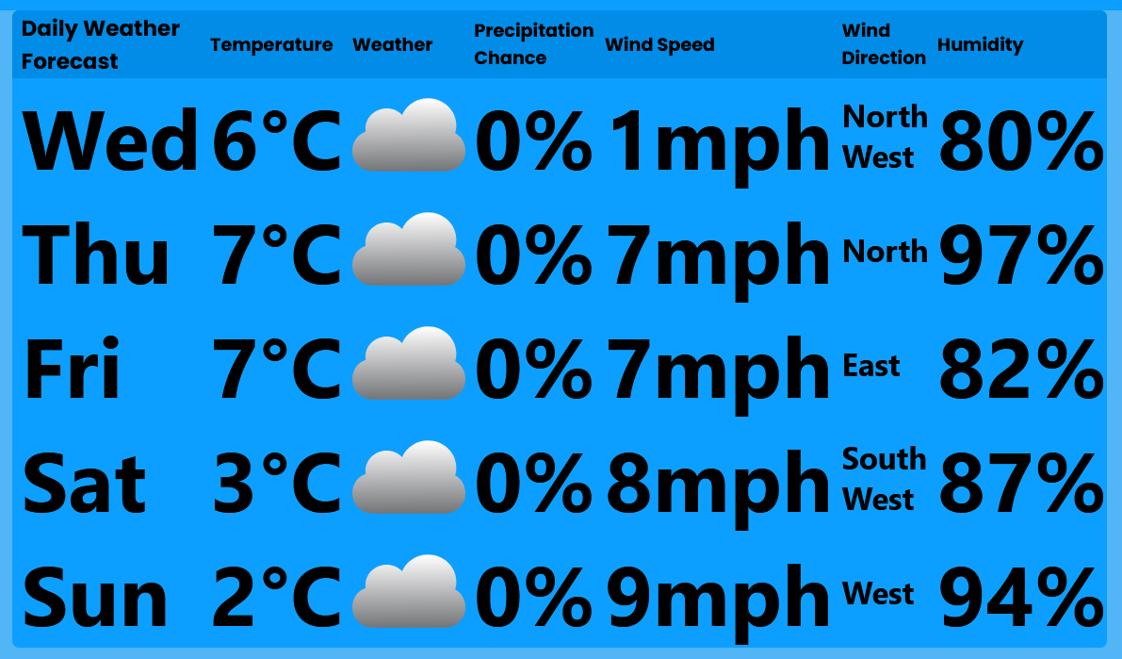

Figure - 5-day daily weather forecast om desktop device.

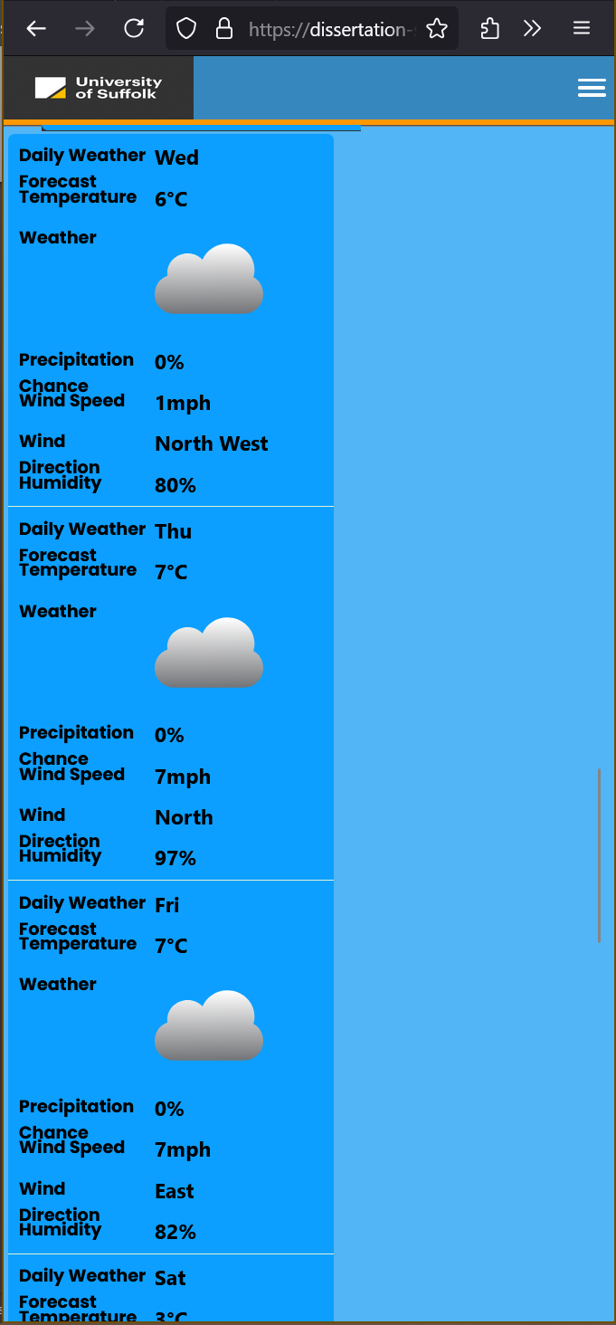

Figure - 5-day daily weather forecast on mobile device.

## View Weather Maps

1. Click “View Full Weather Maps” button on the weather maps tile on the weather dashboard.

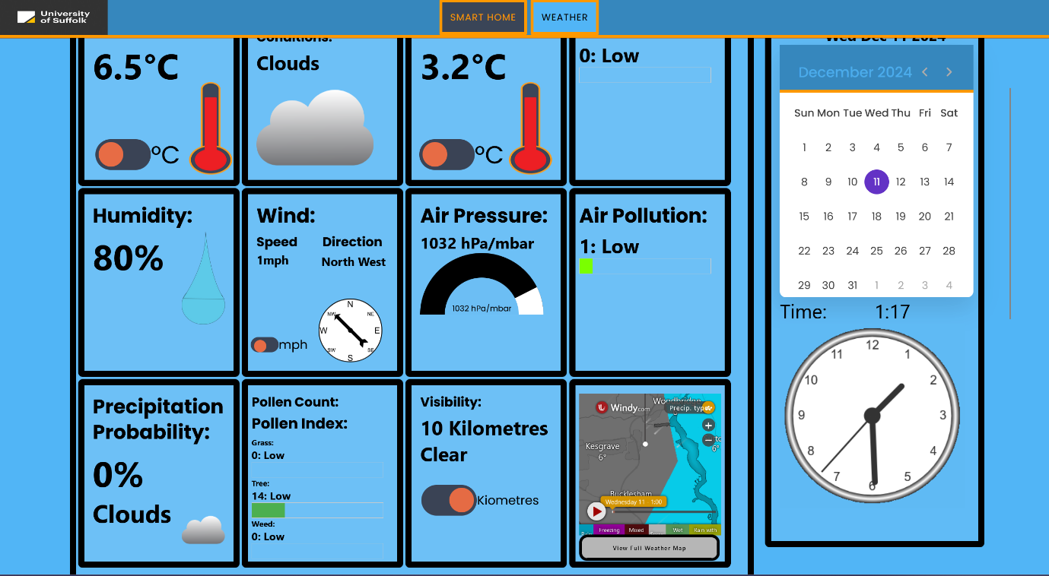

Figure - Select the "View Full Weather Map" button on the weather dashboard.

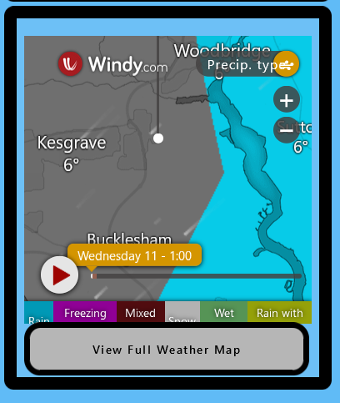

Figure - Click the "View Full Weather Map" button to go the Weather Maps page to view the weather maps.

1. View the weather maps page.

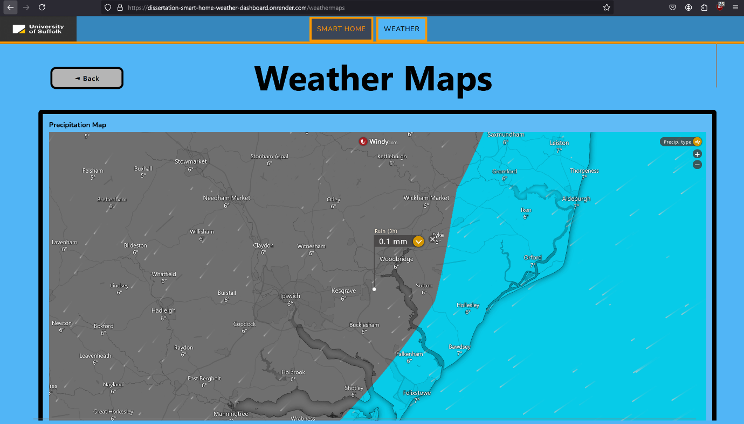

Figure - Precipitation map showing location of precipitation and its type.

1. View, zoom and move around the precipitation map.

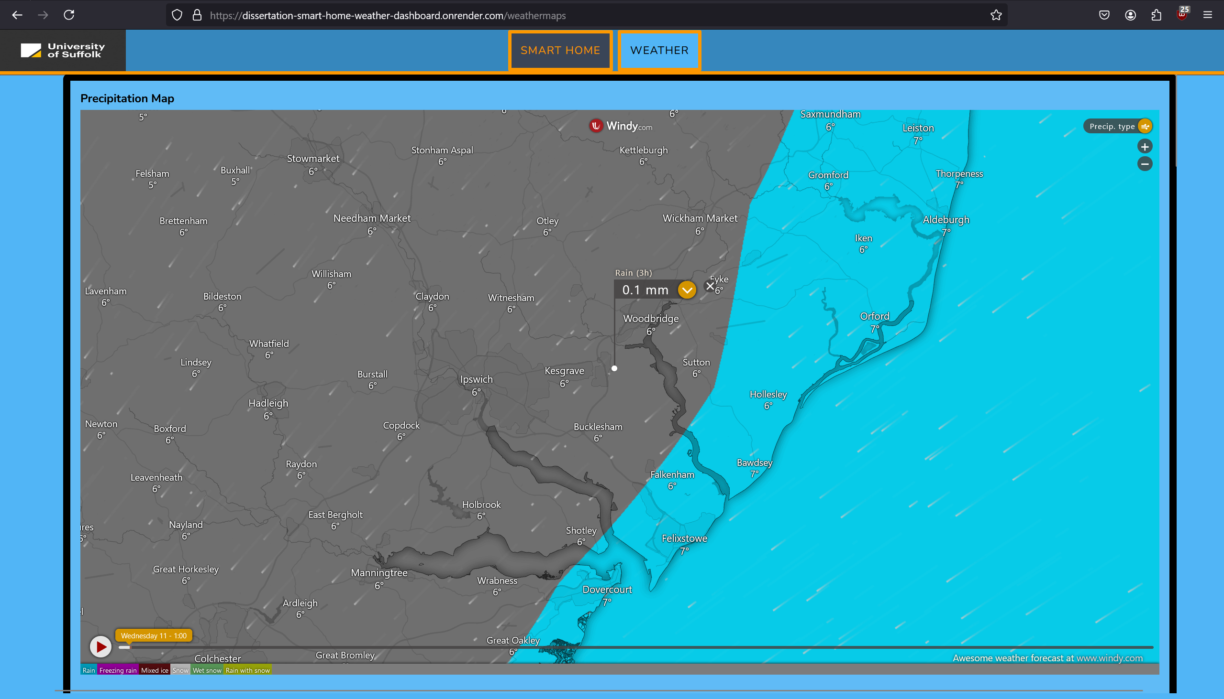

Figure - Precipitation map showing location of precipitation and its type.

1. View, zoom and move around the temperature map.

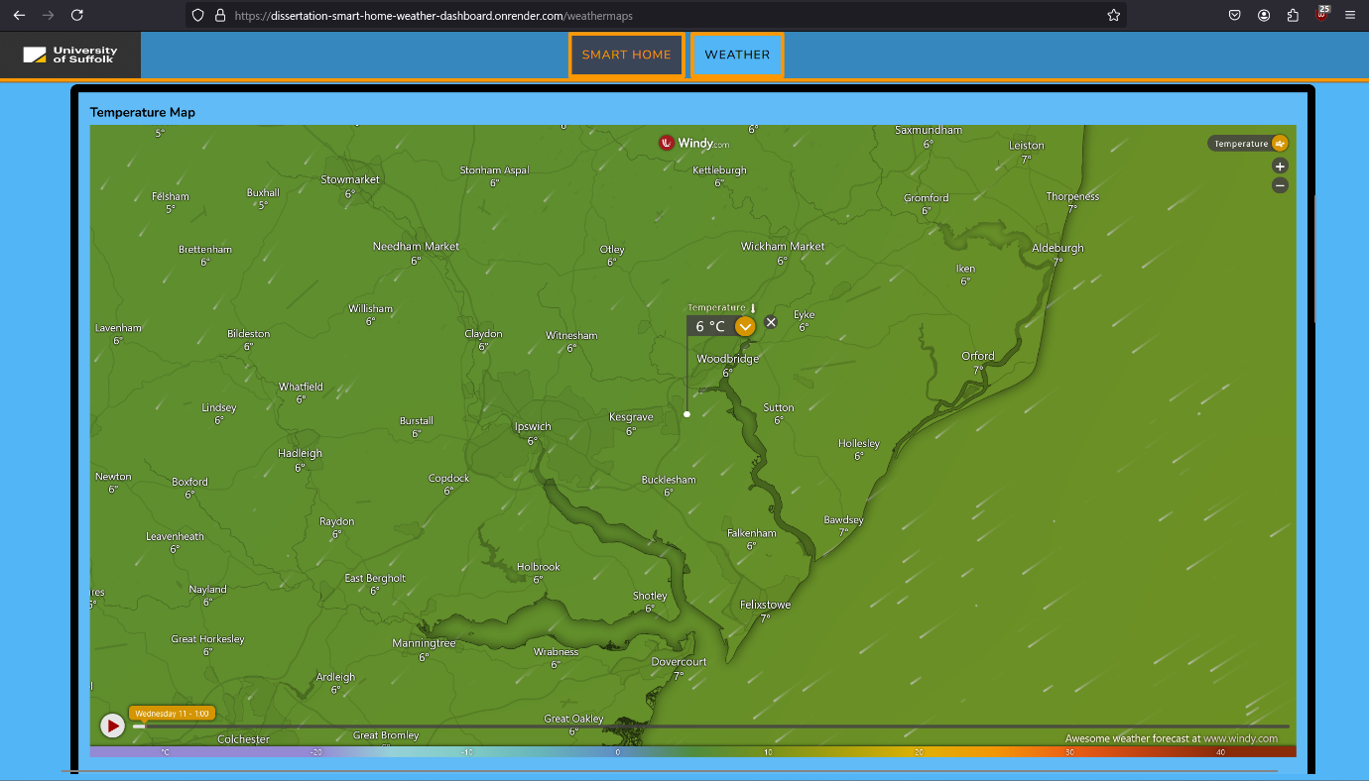

Figure - Temperature map.

1. View, zoom and move around the wind map.

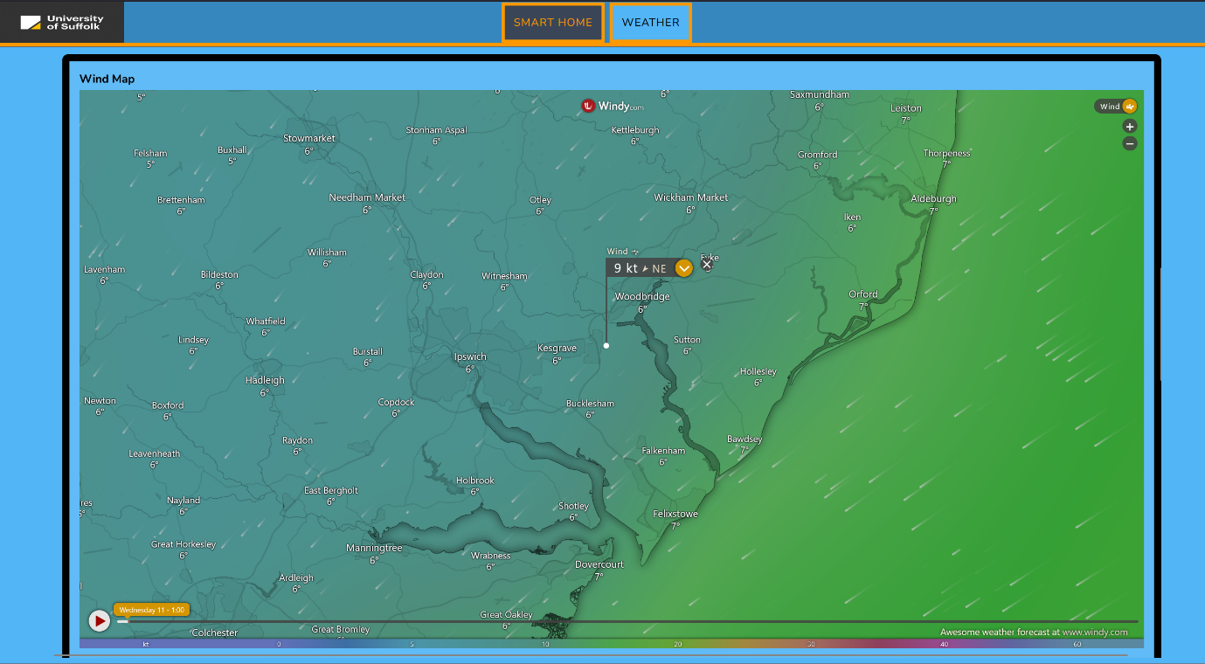

Figure - Wind map.

1. View, zoom and move around the air quality map.

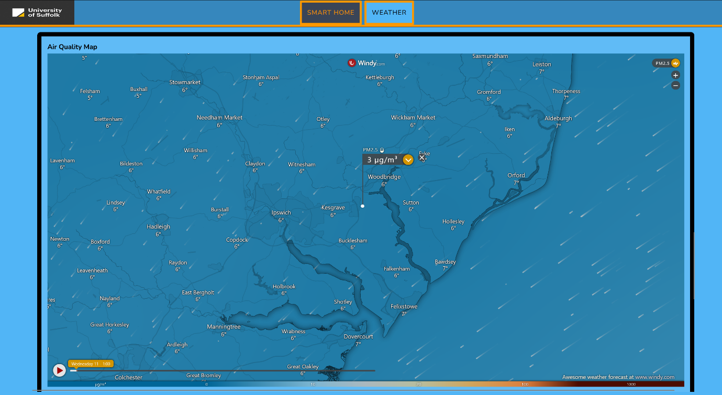

Figure - Air quality map.

1. View, zoom and move around the radar map.

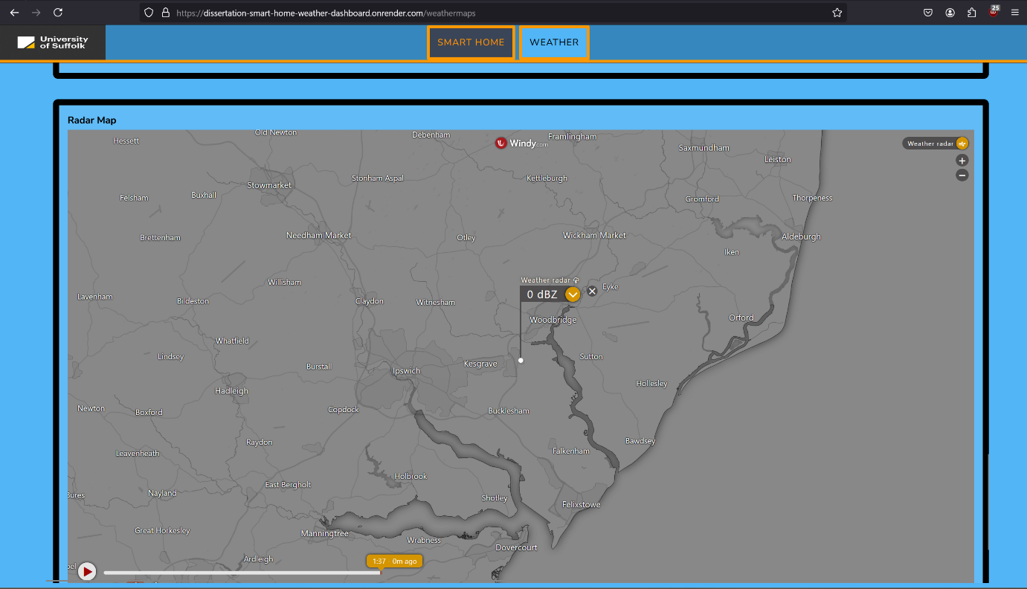

Figure - Radar Map

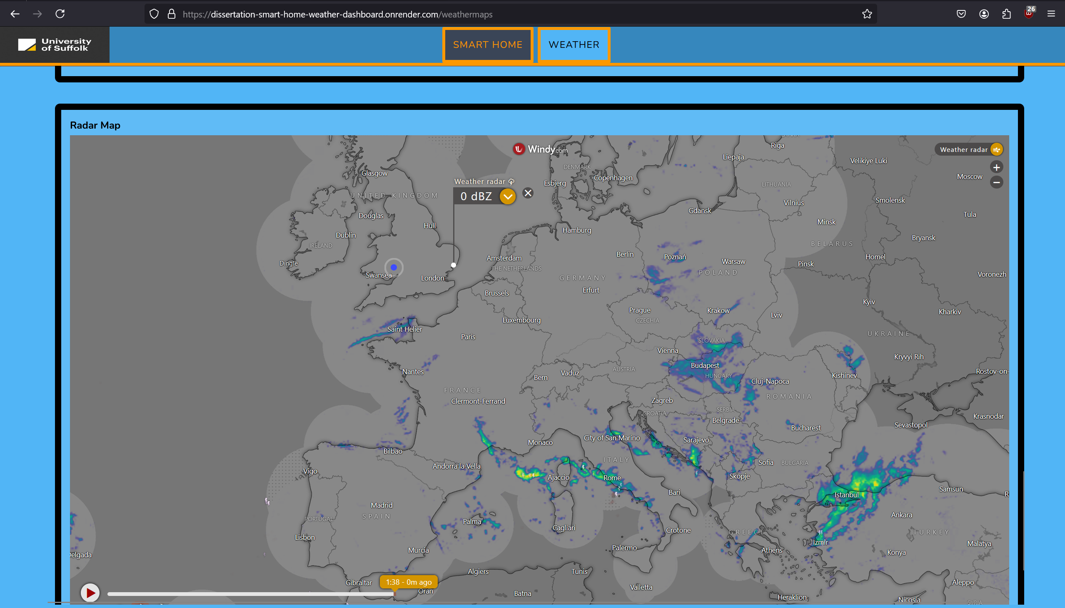

Figure - Radar map zoomed out.

1. Click back button to return to main weather dashboard (desktop devices only).

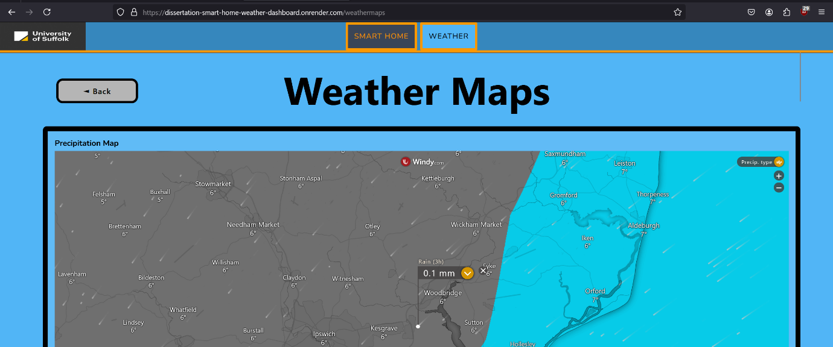

Figure - Click the back button to go back to main weather dashboard (desktop devices only).